**C PROGRAMMING ASSIGNMENT:**

**8**

DATE: 18.11.21

SUBMITTED BY: -

NAME: MUKTESH MISHRA

BRANCH: CSE

SECTION: B22

ROLL NO.: 21052258

**Program 1:** Write a program to display whether the wheatstone bridge is balanced or not.

Code:

#include <stdio.h>

int main(int argc, char const *argv[])

{

    float p, q, r, s;

    printf("Enter 4 resistances P Q R S\n");

    scanf("%f %f %f %f", &p, &q, &r, &s);

    if (p / q == r / s)

    {

        printf("The wheatstone bridge is balanced");

        return 0;

    }

    printf("The wheatstone bridge is not balanced\n");

    s = (r * q) / p;

    printf("Choose s= %f to balance the bridge", s);

    return 0;

}

Output:

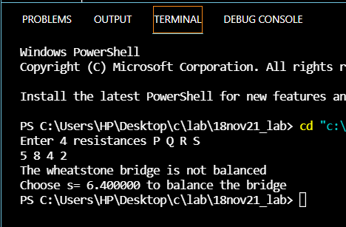

**Program 2:** Write a program to give extra 60 grace marks if age is below 50 else give 40 marks each

i.e., all will get at least 40 marks and people with age below 50 will get additional 20 marks

Code:

#include <stdio.h>

int main(int argc, char const *argv[])

{

    int age, marks;

    printf("Enter the age\n ");

    scanf("%d", &age);

    printf("Enter the marks\n ");

    scanf("%d", &marks);

    marks = marks + 40;

    if (age <= 50)

    {

        marks = marks + 20;

    }

    printf("The total marks:%d\n", marks);

    return 0;

}

Output:

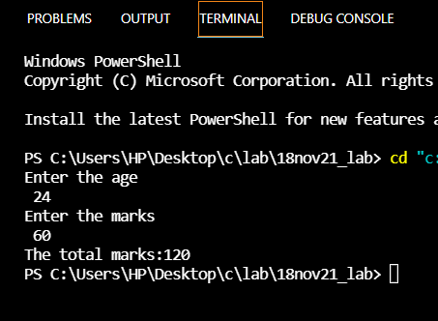ut:

**Program 3:** Write a program if basic salary is < 1500$, then HRA=10% and DA=40% of basic salary else HRA= 500$ and DA=50% of basic salary.Find the gross salary.

Code:

#include <stdio.h>

int main(int argc, char const *argv[])

{

    float bs, hra, da, gs;

    printf("Enter basic salary\n ");

    scanf("%f", &bs);

    if (bs < 1500)

    {

        hra = bs * (10 / 100.);

        da = bs * (40 / 100.);

    }

    else

    {

        hra = 500;

        da = bs * (50 / 100);

    }

    gs = bs + hra + da;

    printf("Gross salary:%f", gs);

    return 0;

}

Output:

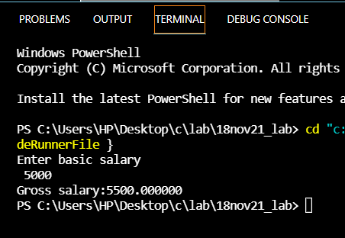

**Program 4:** Write a program to check if 3 points form triangle or not.

Code:

#include <stdio.h>

int main(int argc, char const *argv[])

{

    int m1, m2, m3, x1, x2, x3 , y1, y2, y3;

    printf("Enter the coordinators in form of(x1,y1)\n ");

    scanf("%d %d", &x1, &y1);

    printf("Enter the coordinators in form of(x2,y2)\n ");

    scanf("%d %d", &x2, &y2);

    printf("Enter the coordinators in form of(x3,y3)\n ");

    scanf("%d %d", &x3, &y3);

    m1 = (y2 - y1) / (x2 - x1);

    m2 = (y3 - y2) / (x3 - x2);

    m3 = (y1 - y3) / (x1 - x3);

    if (m1 != m2 && m2 != m3 && m3 != m1)

    {

        printf("Triangle");

    }

    else

    {

        printf("Not a triangle");

    }

    return 0;

}

Output:

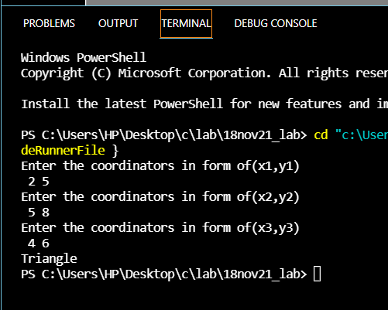

**Program 5:** Write a program to print 'kiit student' if you are in class 1 to class 12 else print kiit univesity student.

Code:

#include <stdio.h>

int main(int argc, char const *argv[])

{

    int c;

    printf("Enter the class\n ");

    scanf("%d", &c);

    if (c <= 12)

    {

        printf("KIIT student");

    }

    else

    {

        printf("KIIT university student");

    }

    return 0;

}

Output:

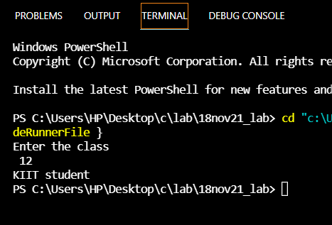

***Program 6: Write a program to print grades inputting marks of 5 subjects.***

Code:

#include <stdio.h>

/* */

int main(int argc, char const *argv[])

{

    int m1,m2,m3,m4,m5,per ;

    printf("Enter the marks of 5 subjects\n ");

    scanf("%d %d %d %d %d", &m1,&m2,&m3,&m4,&m5);

    per= (int) (m1+m2+m3+m4+m5+4.9)/5;

    if (per >= 60)

    {

        printf("First Division");

    }

    if (per >= 50 && per<60 )

    {

        printf("Second Division");

    }

    if (per >= 40 && per<50 )

    {

        printf("Third Division");

    }

    if (per <= 40)

    {

        printf("Fail");

    }

    return 0;

}

Output:

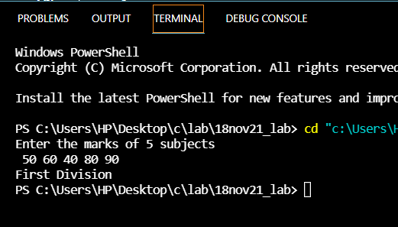

**Program 7:** Wriote a program to enter score of 10 cricket players and countnumber of players scored century. Discard the -ve score if you enter by mistake.

Code:

#include<stdio.h>

int main(int argc, char const *argv[])

{

    int score, i=0,count=0;

    again:

    printf("\n Enter the score of next player no %d =",i);

    scanf("%d",&score);

    if(score<0) goto again;

    if(score>=100)

        count++;

    i++;

    if(i<10) goto again;

    printf("Total no of players made century = %d",count);

    return 0;

}

Output:

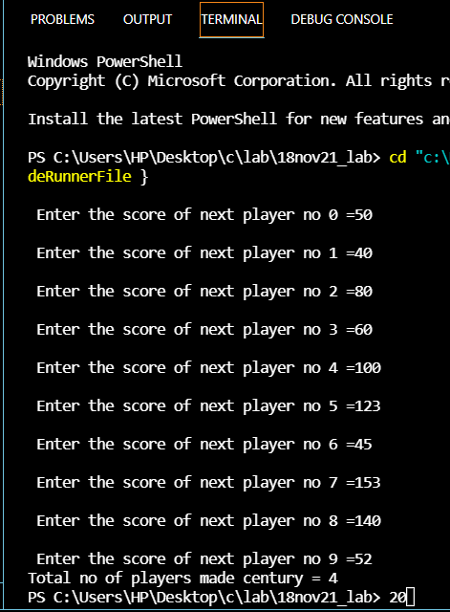

**Program 8:** Write a program given three inputs a,b,c check whether they are sides of a triangle or not .

Code:

#include <stdio.h>

int main(int argc, char const *argv[])

{

    int a,b,c;

    printf("Enter the sides of a triangle\n ");

    scanf("%d %d %d", &a,&b,&c);

    if ((a+b)>c && (b+c)>a && (c+a)>b)

    {

        printf("Sides of a triangle");

    }

    else{

         printf("Not sides of a triangle");

    }

    return 0;

}

Output:

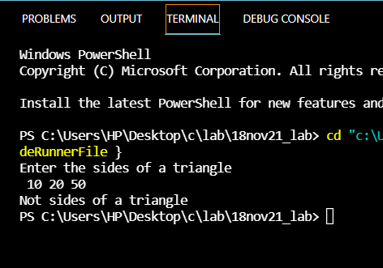

**Program 9:** /*User name == 'a' Passwoord==12345 Check whether Username and password are correct or not*/

Code:

#include <stdio.h>

int main(int argc, char const *argv[])

{

    int pass;

    char usern;

    printf("Enter the Username\n ");

    scanf("%c", &usern);

    printf("Enter the Password\n ");

    scanf("%d", &pass);

    if (usern == 'a')

    {

        if (pass == 12345)

        {

            printf("Login successful\n");

        }

        else

        {

            printf("Login failed\n");

        }

    }

    else

    {

        printf("Wrong username");

    }

    return 0;

}

Output:

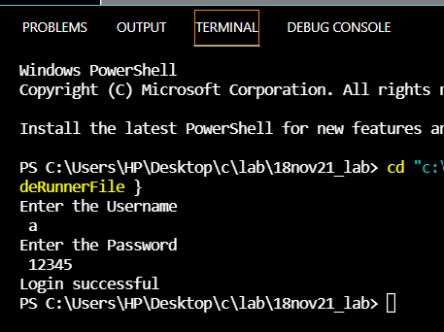

**Program 10:** /*write a program to display whether a vehicle is moving with constant velocity/acceleration

deceleration  Input: a*/

Code:

#include <stdio.h>

int main(int argc, char const *argv[])

{

    int a;

    printf("Enter the value of a\n ");

    scanf("%d", &a);

    if (a>0)

    {

        printf("Constant velocity\n");

    }

    if (a==0)

    {

        printf("accelerated velocity\n");

    }

    if(a<0)

    {

        printf("Decceleration velocity\n");

    }

    return 0;

}

Output:

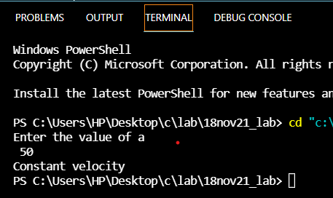

**Program 11:** /*Write a program to find greatest no*/

Code:

#include <stdio.h>

int main(int argc, char const *argv[])

{

    int a, b, c;

    printf("Enter the 3 nos\n ");

    scanf("%d %d %d", &a, &b, &c);

    if (a > b && a > c)

    {

        printf("%d is greatest", a);

    }

    if (b > a && b > c)

    {

        printf("%d is greatest", b);

    }

    if (c > b && c > a)

    {

        printf("%d is greatest", c);

    }

    return 0;

}

Output:

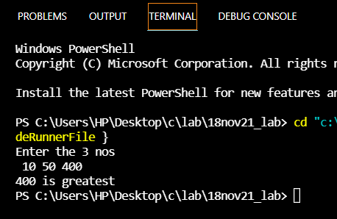

**Program 12:** /*Concave mirror*/

Code:

#include <stdio.h>

int main(int argc, char const *argv[])

{

   int a;

   printf("Enter 1 for position of object at infinity\n ");

   printf("Enter 2 for position of object beyond C\n ");

   printf("Enter 3 for position of object at C\n ");

   printf("Enter 4 for position of object Between c and F\n ");

   printf("Enter 5 for position of object at F\n ");

   printf("Enter your choice\n ");

   scanf("%d", &a);

   if (a == 1)

   {

      printf("Position of image at F\nSize of image:Highly diminished\nNature of image:Real and inverted");

   }

   if (a == 2)

   {

      printf("Position of image Between C and F\nSize of image: diminished\nNature of image:Real and inverted");

   }

   if (a == 3)

   {

      printf("Position of image at C\nSize of image:Same size\nNature of image:Real and inverted");

   }

   if (a == 4)

   {

      printf("Position of image Beyond C\nSize of image:Enlarged\nNature of image:Real and inverted");

   }

   if (a == 5)

   {

      printf("Position of image at infinity\nSize of image:Highly Enlarged\nNature of image:Real and inverted");

   }

   else

   {

      printf("Invalid choice");

   }

   return 0;

}

Output:

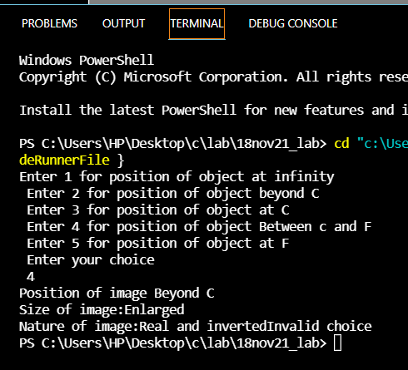

**Program 13:** /*Find the output*/

Code:

#include <stdio.h>

int main()

{

    int a = 0, b;

    if (a < 1)

        printf("XXX"); // Block L1

    printf("YYY\n");   // L2

    if (a > 1)

        printf("000"); // Block

    printf("111 \n");

    if (a = 1)

        printf("Comp Sc");     // Block L1

    printf(" Engineering \n"); // L2

    if (b = a++)

        printf("\nComp Sc");  // Block L1

    printf(" Engineering\n"); // L2

    if (b = ++a)

        printf("\nComp Sc");  // Block L1

    printf(" Engineering\n"); // L2

    return 0;

}

Output:

